**CHAPTER-1**

**INTRODUCTION**

* 1. **ABOUT PROJECT**

This Design and Development of Event Management System (EMS) is a desktop-based system software application aimed at event head, coordinators and administrators for providing the convincing facility to plan, organize, update, and manage events without running into a problem. Its work is to maintain and regulate the smooth process of the event until its execution without any delay and waste of time and resources. Administration (The one who maintains the manages the coordinators) and Coordinators who are responsible for the event execution. It allows flexibility in the database of the system. This is one of the proposed solutions that can be used by many colleges, firms, and others for event management to regulate the flow of the function or event without running into a problem at the eleventh hour.

It provides a centralized platform for event organizers to manage their events and keep track of their progress. It also helps to ensure that all aspects of the event are taken care of, from venue selection to budgeting.

* 1. **PROJECT OBJECTIVES**

The main objective of the project is to provide the functionality of adding events, updating, paying, login, registering to, participating in events, managing events, and getting status. This makes it easier for all the users and coordinators to participate in and manage the events.

* + 1. **FUNCTIONALITY**

The website application will provide the following features:

* People will able to see the latest updates regarding the change in the event, participate in the event.
* Issue certificate.
* Manage the event.
  1. **INTERFACE**

This website interacts with the users through any browser. The interface is simple, easy to handle, user will easily come in to the flow with the website and easily uses all interfaces properly.

* 1. **DESIGN AND IMPLEMENTATION CONSTRAINTS**
* The information of all users related to the login is available in a database accessible by the Admin.
* All the other details of the database are accessible by the Admin.
* The data is stored in a single database so it’s prone to lose due to digital and physical calamities.
* The application requires an internet connection for all its activity.
* SQLite is used for databases and it is only suitable for small projects.
* The website application is available only in English.
  1. **ASSUMPTIONS AND DEPENDENCIES**

The solution to the problem relies on the following aspects:

* Admin will add and update Events.
* Users will be able to provide their feedback on their experience.
  1. **USER DOCUMENTATION**

This project will deliver documents in PDF format, including:

* Description for installing and running Design and Development of Event Management System.
* Description of using Event Management System web application.

**CHAPTER-2**

**SOFTWARE & HARDWARE REQUIREMENTS**

**2.1 INTRODUCTION**

The software and hardware components of a computer system those are required to install and use application efficiently. The application manufacturer will list the system requirements on the package. If your computer system does not meet the system requirements then the application may not work correctly after installation. System requirement for operating system will be hardware components, while other application software will list both hardware and operating system requirements and Brower. System requirements are most commonly seen listed as minimum and recommended requirements The minimum system requirements need to be met for the web application to run at all on your system, & the recommended system requirements, if met, will offer better software usability.

* 1. **SOFTWARE REQUIREMENTS**

There are following software requirements to work on this project:

* + 1. **For Developers:** 
       1. **Integrated Development Environment (IDE).**

Microsoft Visual Studios Code.

* + - 1. **Front-End:**
* HTML 5 (Hyper Text Markup Language).
* CSS (Cascading Style Sheet).
* JavaScript.
  + - 1. **Back-End:**
* Django Framework
* SQLite database
  + 1. **For End Users**
* Google chrome (latest version i.e., chrome 111.0.5563.147) or Others Older Versions.
* Mozilla Firefox (latest version i.e., Firefox 102.0) or Others Older Versions.
  + 1. **Description** 
       1. **HTML**

HTML stands for Hyper Text Markup Language. It is the standard markup language for creating Web pages, it describes the structure of a Web page. HTML consists of a series of elements these elements tell the browser how to display the content. HTML elements label pieces of content such as "this is a heading", "this is a paragraph", "this is a link", etc. receive HTML documents from a web server or from local storage and render the documents into multimedia web pages. HTML describes the structure of a web page semantically and originally included cues for the appearance of the document. HTML can embed programs written in a scripting language such as JavaScript, which affects the behaviour and content of web pages. Inclusion of CSS defines the look and layout of content. The World Wide Web Consortium (W3C), former maintainer of the HTML.

* + - 1. **CSS**

Cascading Style Sheets (CSS) is a stylesheet language used to describe the presentation of a document written in HTML or XML (including XML dialects such as SVG, MathML or XHTML). CSS describes how elements should be rendered on screen, on paper, in speech, or on other media.

CSS is among the core languages of the open web and is standardized across Web browsers according to W3C specifications. Previously, development of various parts of CSS specification was done synchronously, which allowed versioning of the latest recommendations. You might have heard about CSS1, CSS2.1, CSS3. However, CSS4 has never become an official version.

* + - 1. **JAVASCRIPT**

JavaScript is a text-based programming language used both on the client-side and server-side that allows you to make web pages interactive. Where HTML and CSS are languages that give structure and style to web pages, JavaScript gives web pages interactive elements that engage a user.

Incorporating JavaScript improves the user experience of the web page by converting it from a static page into an interactive one. To recap, JavaScript adds behaviour to web pages.

JavaScript is mainly used for web-based applications and web browsers. But JavaScript is also used beyond the Web in software, servers and embedded hardware controls.

* + - 1. **Visual Studio Code**

Visual Studio Code features a lightning-fast source code editor, perfect for day to-day use. With support for hundreds of languages, VS Code helps you be instantly productive with syntax highlighting, bracket-matching, auto indentation, box-selection, snippets, and more. Intuitive keyboard shortcuts, easy customization and community-contributed keyboard shortcut mappings let you navigate your code with ease.

For serious coding, you'll often benefit from tools with more code understanding than just blocks of text. Visual Studio Code includes built-in support for IntelliSense code completion, rich semantic code understanding and navigation, and code refactoring.

And when the coding gets tough, the tough get debugging. Debugging is often the one feature that developers miss most in a leaner coding experience, so we made it happen. Visual Studio Code includes an interactive debugger, so you can step through source code, inspect variables, view call stacks, and execute commands in the console.

VS Code also integrates with build and scripting tools to perform common tasks making everyday workflows faster. VS Code has support for Git so you can work with source control without leaving the editor including viewing pending changes diffs.

* + - 1. **Django**

Django is a high-level Python web framework that encourages rapid development and clean, pragmatic design. Built by experienced developers, it takes care of much of the hassle of web development, so you can focus on writing your app without needing to reinvent the wheel. It’s free and open source, has a thriving and active community, great documentation, and many options for free and paid-for support.

* 1. **HARDWARE REQUIREMENTS**
* Operating System: Windows XP, Windows 7, Windows 8, Windows 10
* Processor: Core i3, 2.6GHz
* Hard Disk: 150 GB
* RAM: 8 GB
* Proper Internet connection.

**CHAPTER-3**

**PROBLEM DISCRIPTION**

**3.1 OVERVIEW**

As we all know that at occasions, events are conducted and for that there exist problems regarding event management on those occasions, to overcome this problem, we have proposed a solution known as event management system.

Example-1-

Suppose during the fiesta or some other functions number of events are conducted and for its successful conduction and execution of it, its management is required, this web-based software provides a one in all platform for its management.

Example-2-

Suppose Event named as ‘A’ has to be organized, for the same it’s management like the day it is to be conducted, number of attendees, number of participants, winner, prized and all other can be managed in this particular platform.

Event Management System (EWS) is an integrated electronic management system. This system ensures that the management process is smoothly done. This system will also help in decreasing errors mostly caused by human mistakes; it also reduces the time. This system is developed as one of the solutions to transfer from current manual practices to a more systematic computerized system. “To introduce an online platform where one can, solve and resolve all of its doubts, requests, updates, changes in an event and for many such various events.” This is an all-in-one online platform for event management.

EMS is designed in such a way that it makes event planning easier and more efficient. It provides a centralized platform for event organizers to manage their events and keep track of their progress.

It also helps to ensure that all aspects of the event are taken care of, from venue selection to budgeting.

**CHAPTER-4**

**LITERATURE SURVAY**

The objective of this project is to develop a web application which will provide an interesting news and events so that users will be able to manage their event smoothly. The objective of this project is to develop a web application which will provide an interesting news and events so that users will be able to manage their event smoothly. Event organizers are continually appreciating the benefits of an online event management system such as an Event management application. Organizing an event is not an easy task, especially if the target audience is of a substantial size and if there are many teams involved during the execution phase. For this reason, automating the processes found in the event planning life cycle is a godsend to organizers who are still using old school methods. An online management system practically automates the organizing process and leaves lesser room for human error.

This web application is design which could effectively manage the event in an organization. This web application contains the database which has the details of the participants, their name, and the events they are willing to participate, their registration ID, and event details like day, venue, time, etc. Instead of using paperwork, participant can simply use this web application to register. Events Management System is very helpful for events. This web application being as a platform to know the events, to apply for the events. Event organizer is a web application under project management for managing festivals or social events like gathering, colleges, events, conferences etc. Lastly, this web application can be access everywhere, anytime as everybody have their own smartphone.

**CHAPTER-5**

**SOFTWARE REQUIREMENTS SPECIFICATION**

* 1. **FUNCTIONAL REQUIREMENTS:**
     1. **FUNCTION MANAGE ADMIN**
* Login/Logout
* Manage participant
* Manage event head
* Manage co-ordinate
* Manage event committee
* Manage Events
* View Payments
* Manage Colleges
* Manage stream
* Manage News
  + 1. **FUNCTION MANAGE COORDINATOR**
* Login/Logout and Register
* Confirm participants
* Participants certificate issue
* Winner certificate issue
  + 1. **FUNCTION MANAGE EVENT HEAD**
* Login/Logout and Register
* Participants list and attendance
* Add result
  + 1. **FUNCTION MANAGE PARTICIPANT**
* Register
* Login/Logout
* View Event status
* Pay fees
* View certificate
  1. **NON-FUNCTIONAL REQUIREMENTS:**

A non-functional requirement is a requirement that specifies criteria that can be used to judge the operation of a system, rather than specific behaviours. They are contrasted with functional requirements that define specific behaviour or functions. A careful specification and adherence of non-functional requirements such as performance, security, privacy & availability are crucial to the success or failure of any software system. The correct specification and adherence of non-functional requirements similarly plays at least an equal, if not a greater role in the success of mobile applications.

* + 1. **Usability**: In this system, user experience has very smooth to both user and admin.
    2. **Reliability**: This system has available and satisfy Admin's and user's needs
    3. **Performance**: This application has guaranteed a short response time of requests regardless of the number’s users connected to the system at a specific time.
    4. **Availability**: This system has always available for the users. The server up-time should be around 99.99% allowing for a small time of down time (if necessary)
    5. **Extensibility**: This system has designed in such a way to accommodate future development across different platform (like mobile, web, desktop)
    6. **Security**: This system has offered a secure authentication to the platform.
    7. **Maintainability**: This system is easy to maintain admins. This system helps both to make their work easy and simple
    8. **Supportability**: The code and supporting modules of this system will be well documented and easy to understand.

**CHAPTER-6**

**SOFTWARE DESIGN**

* 1. **E-R DIAGRAM**

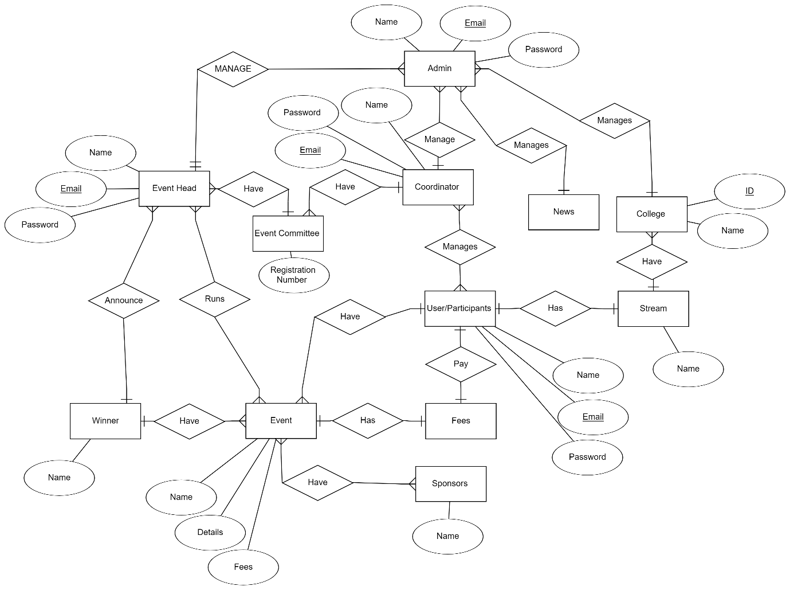

Fig 6.1 ER Diagram

* 1. **USE CASE DIAGRAM**

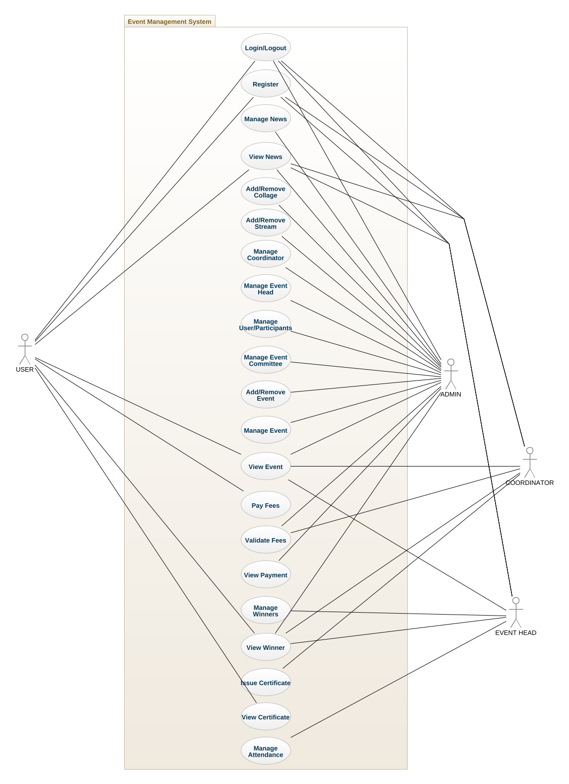

Fig 6.2 Use Case Diagram

* 1. **CLASS DIAGRAM**

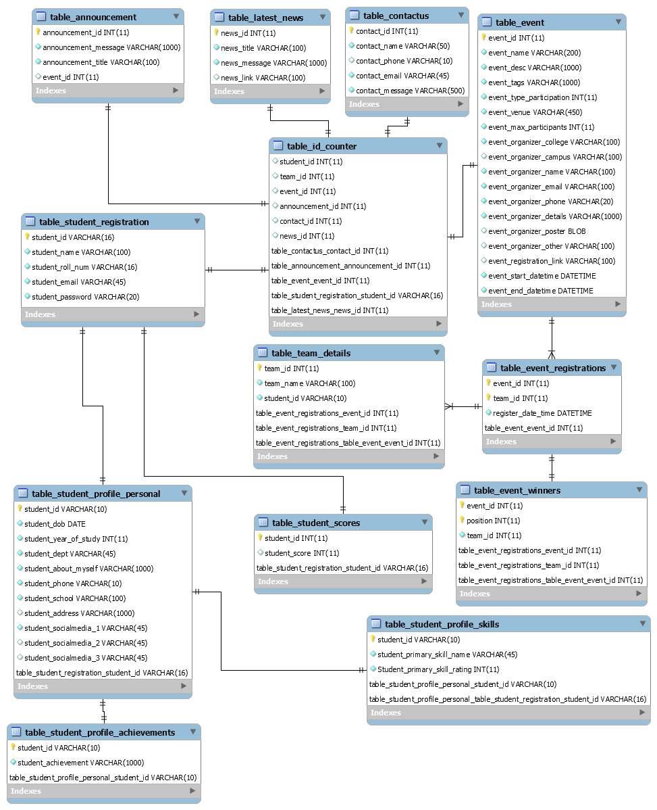

Fig 6.3 Class Diagram

**CHAPTER-7**

**OUTPUT SCREEN**

**OUTPUT SCREEN OF EVENT MANAGEMENT SYSTEM**

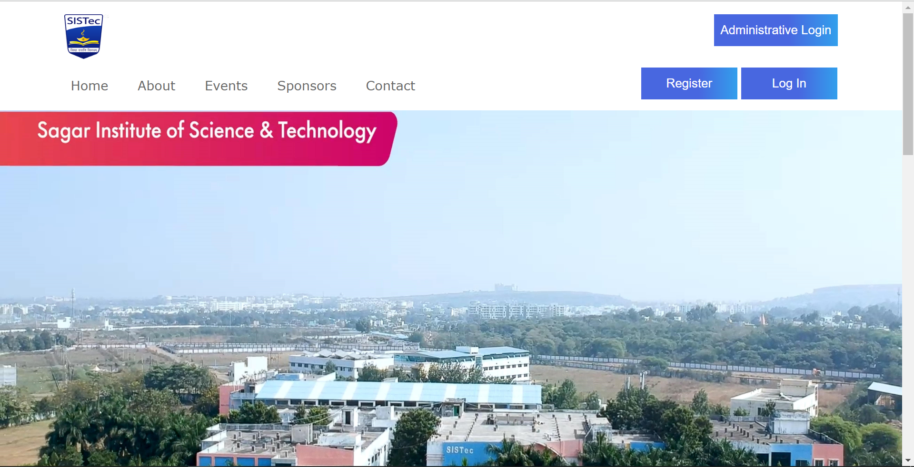

Fig 7.1 Home Page (without login)



Fig 7.2 Home Page (2)

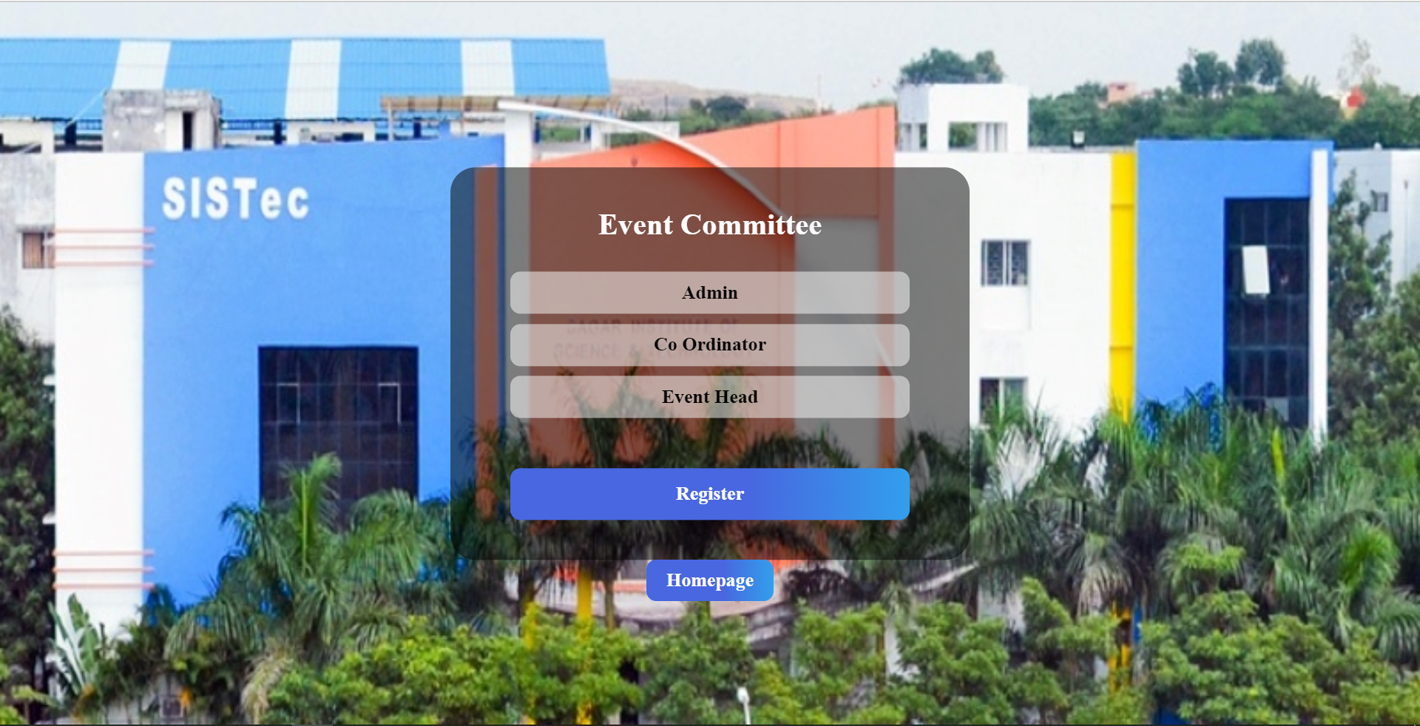

Fig 7.3 Login Options

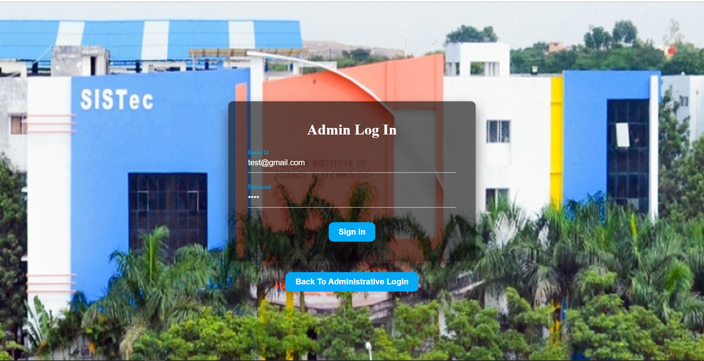

Fig 7.4 Admin login

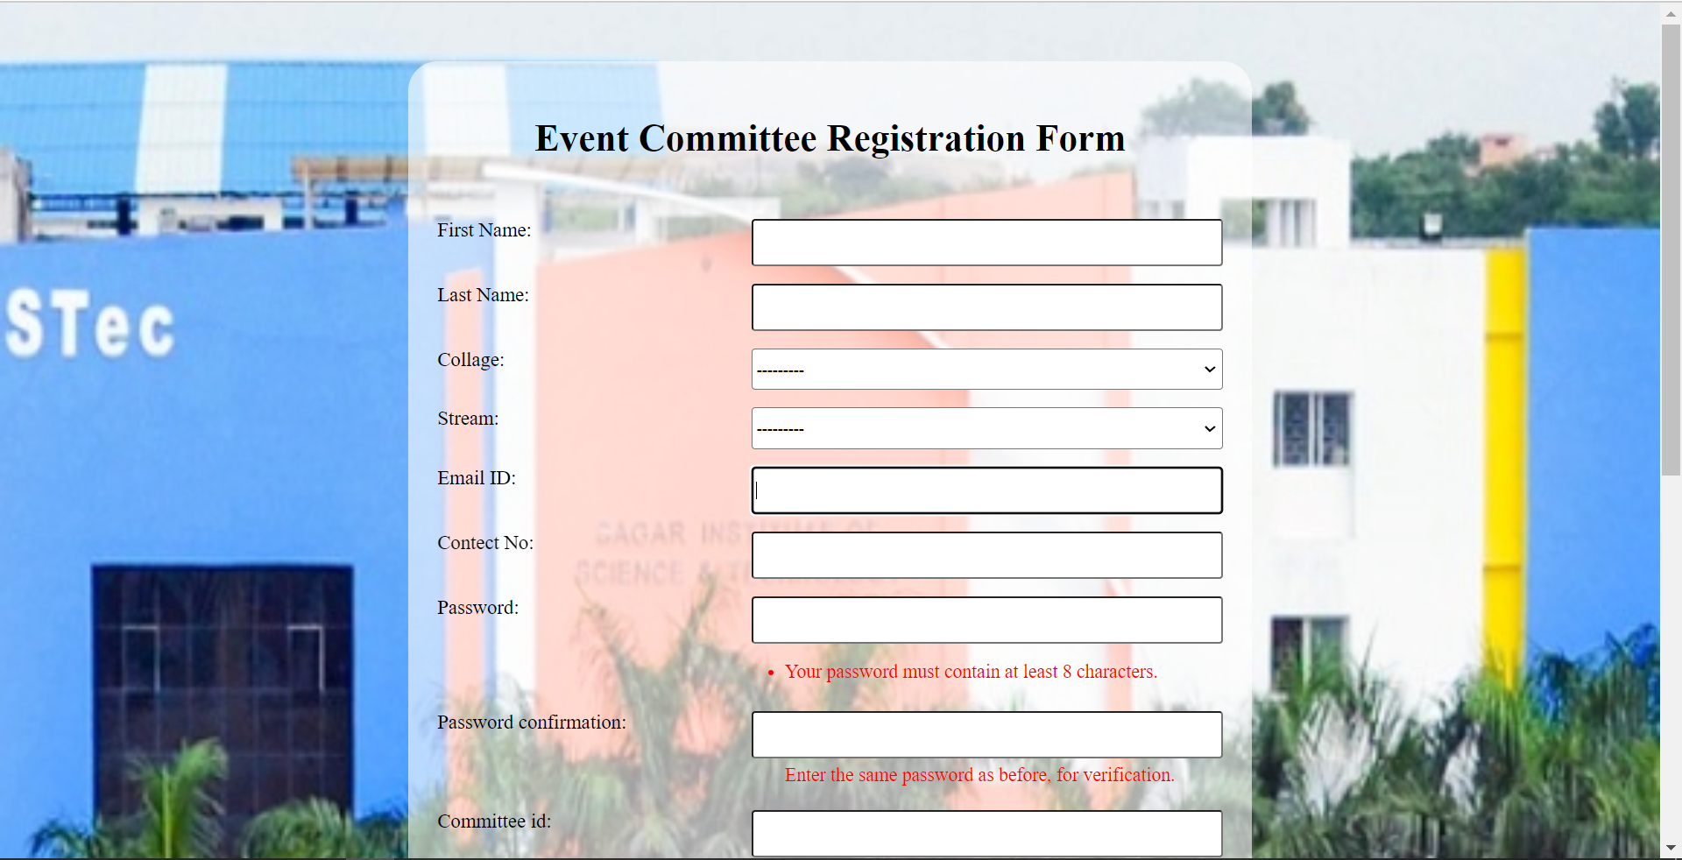

Fig 7.5 Registration form for coordinator and event head

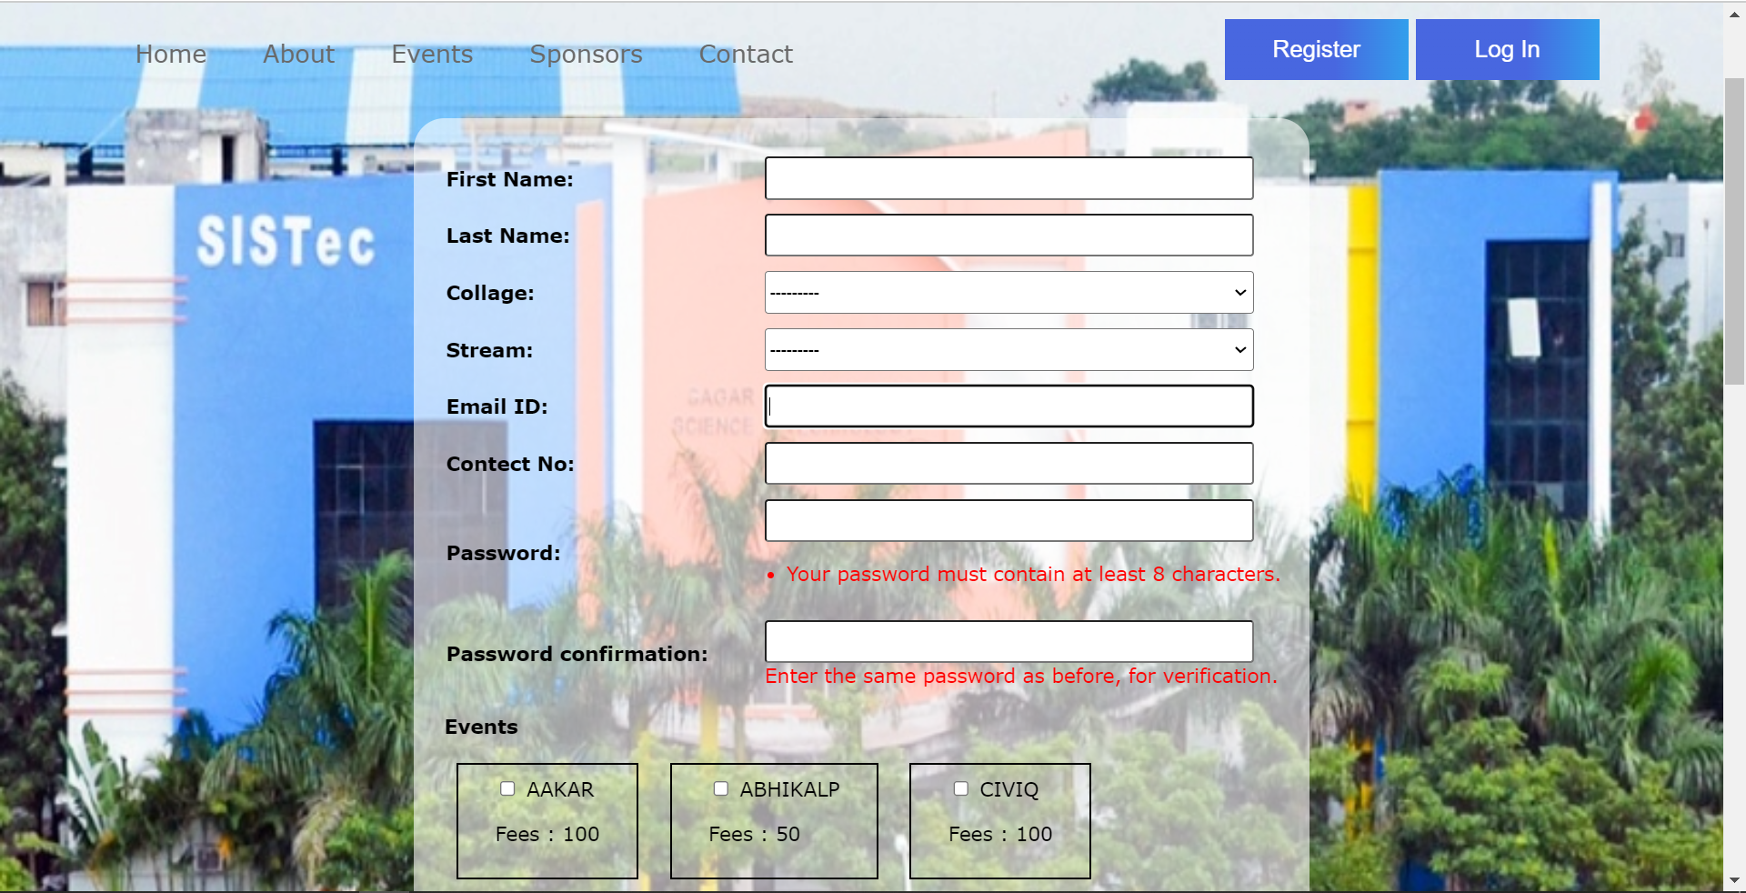

Fig 7.6 Participants Registration

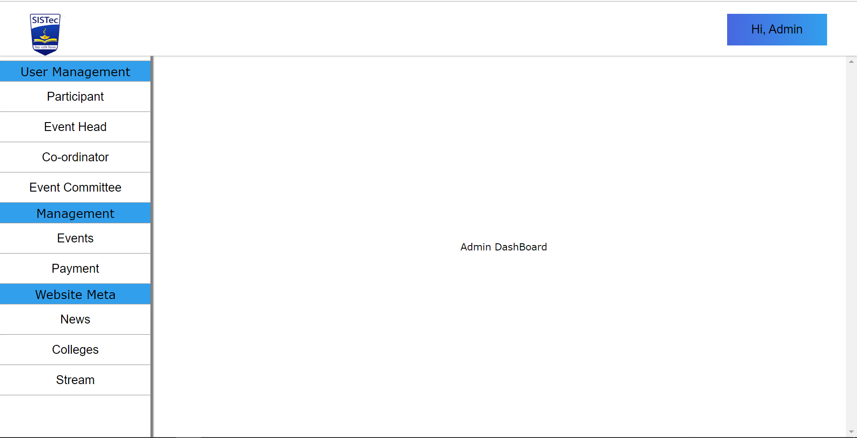

Fig 7.7 Admin Panel

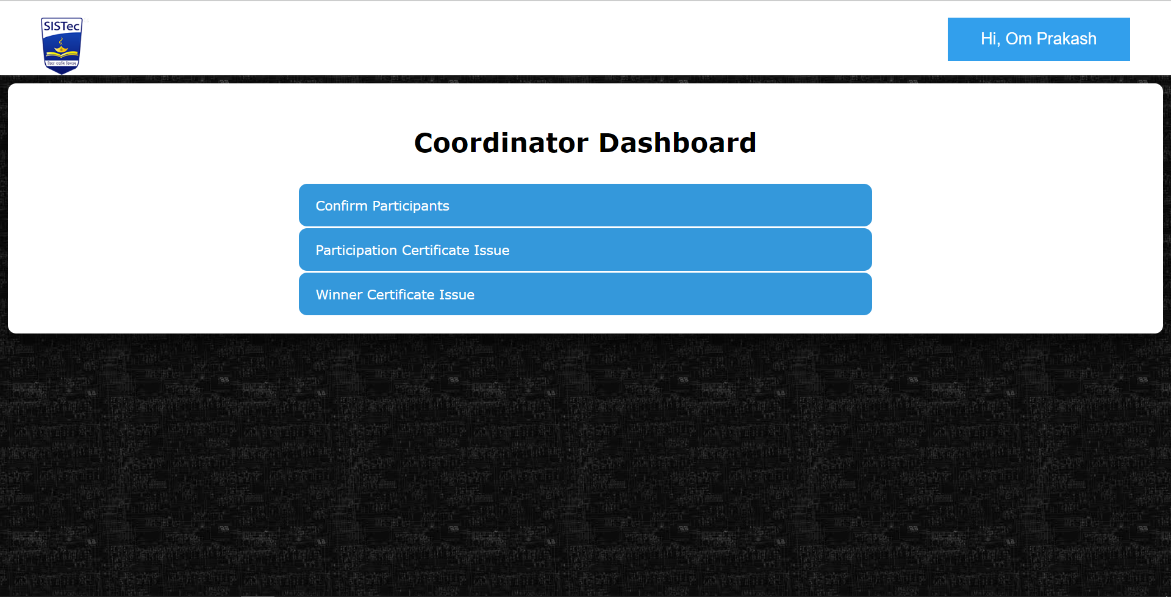

Fig 7.8 Coordinator Panel

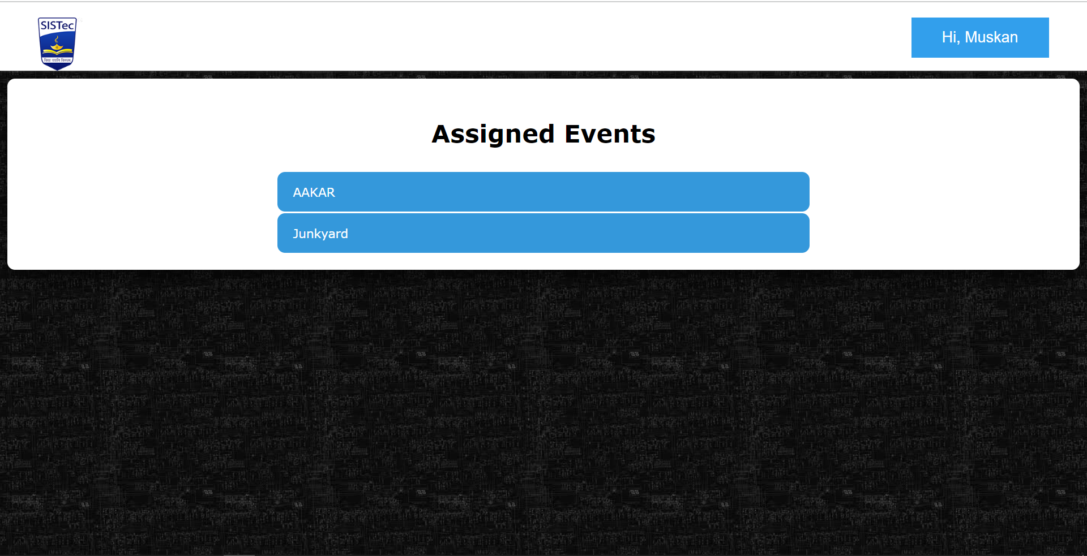

Fig 7.9 Event Head Panel

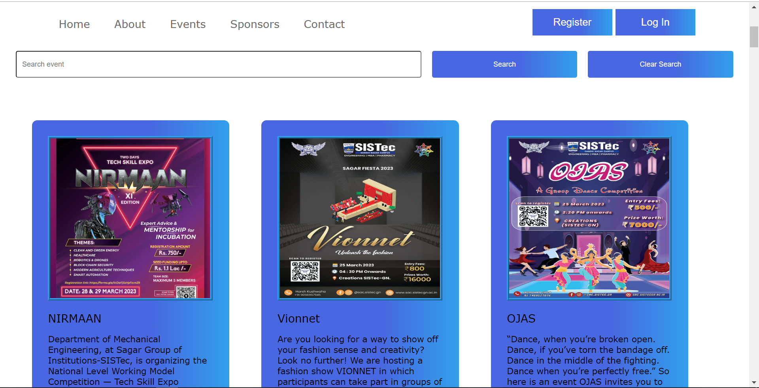

Fig 7.10 Events Page

**CHAPTER-8**

**DEPLOYMENT**

* 1. **INTRODUCTION**

This chapter describes how to deploy the project on a fresh machine. It includes Installation steps & snapshots of pre-required software’s like Visual Studio code. Installation steps & snapshots of the website developed under the major project. Visual Studio is the official Integrated Development Environment (IDE) for Website development software. On top of powerful code editor and developer tools, Visual Studio code offers even more features that enhance your productivity when building Website.

* 1. **INSTALLATION OF VISUAL STUDIO CODE**

### **8.2.1 Download Visual Studio Code:**

You can download Visual Studio code from URL **"**<https://code.visualstudio.com/download>**"** by selecting the right platform:

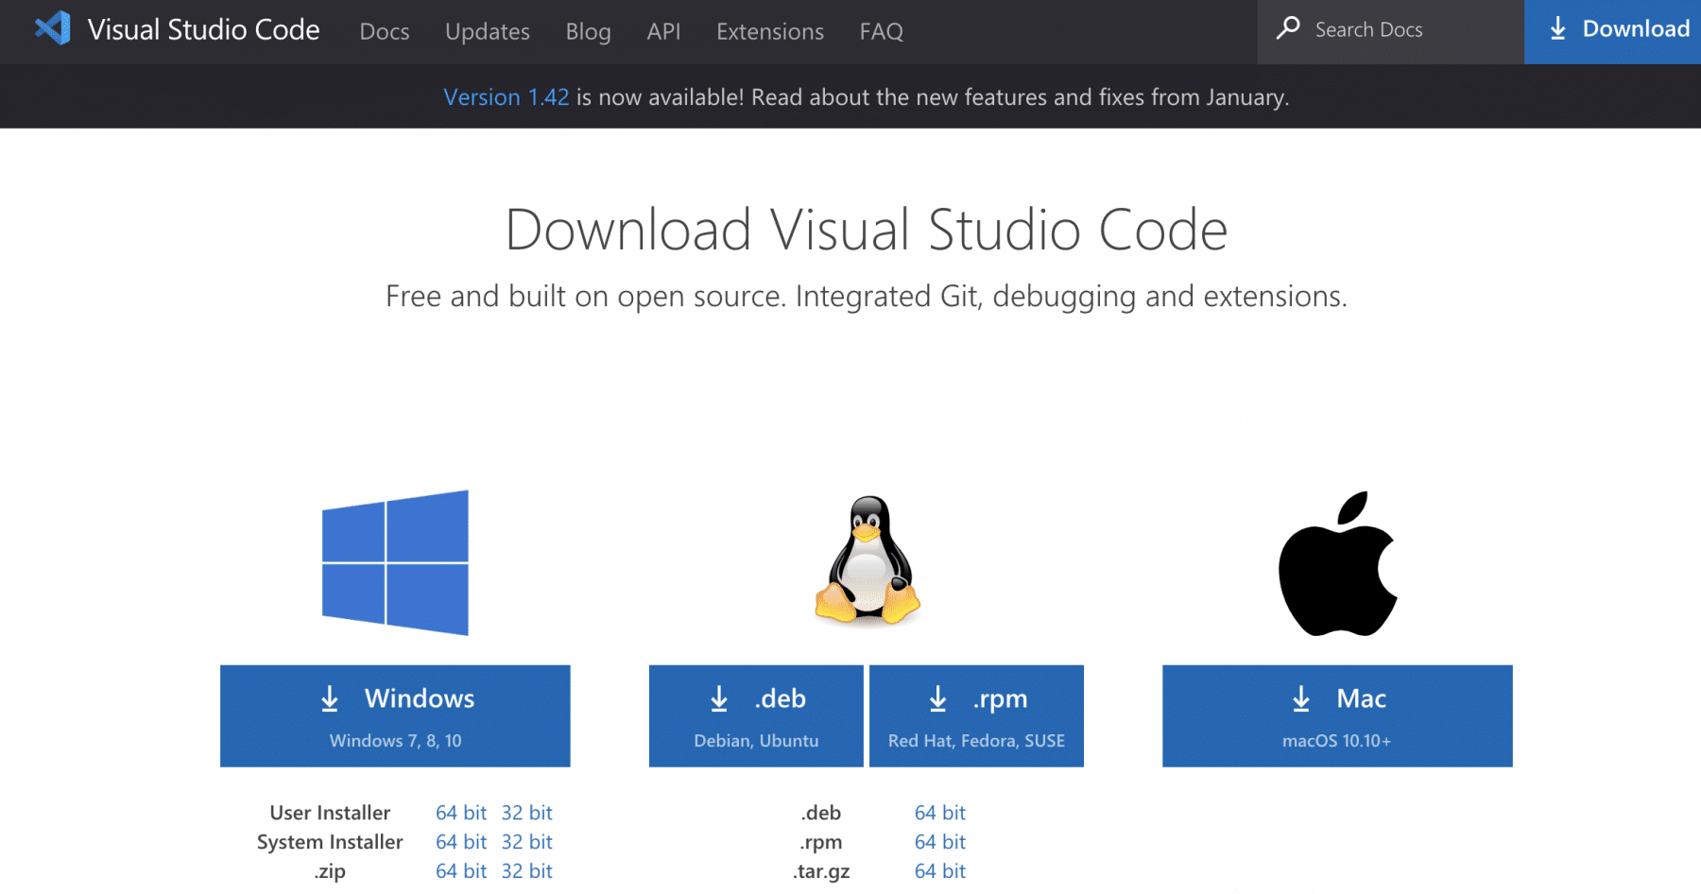

Fig 8.1 Downloading window of visual studio code

You can click any of the icons mentioned above, depending on the operating system for which you are planning to download the visual studio code editor.

### **How to install Visual Studio Code on macOS?**

Follow the below steps*(shown in gif file and mentioned in bullet points) * to install the VS Code on macOS:

1. Download Visual Studio Code for macOS.
2. After clicking on the Mac option on the download site, it will download a zip file, as shown below:
3. Double-click on the downloaded zip to expand the contents. It will give a file, as shown below:
4. Drag **"Visual Studio Code.app"** to the **"Applications"** folder, so as it available in the **"Launchpad."**
5. Double click on the **"Visual Studio Code"** to open.
6. Add VS Code to your Dock by right-clicking on the icon to bring up the context menu and choosing **Options => Keep in Dock.**

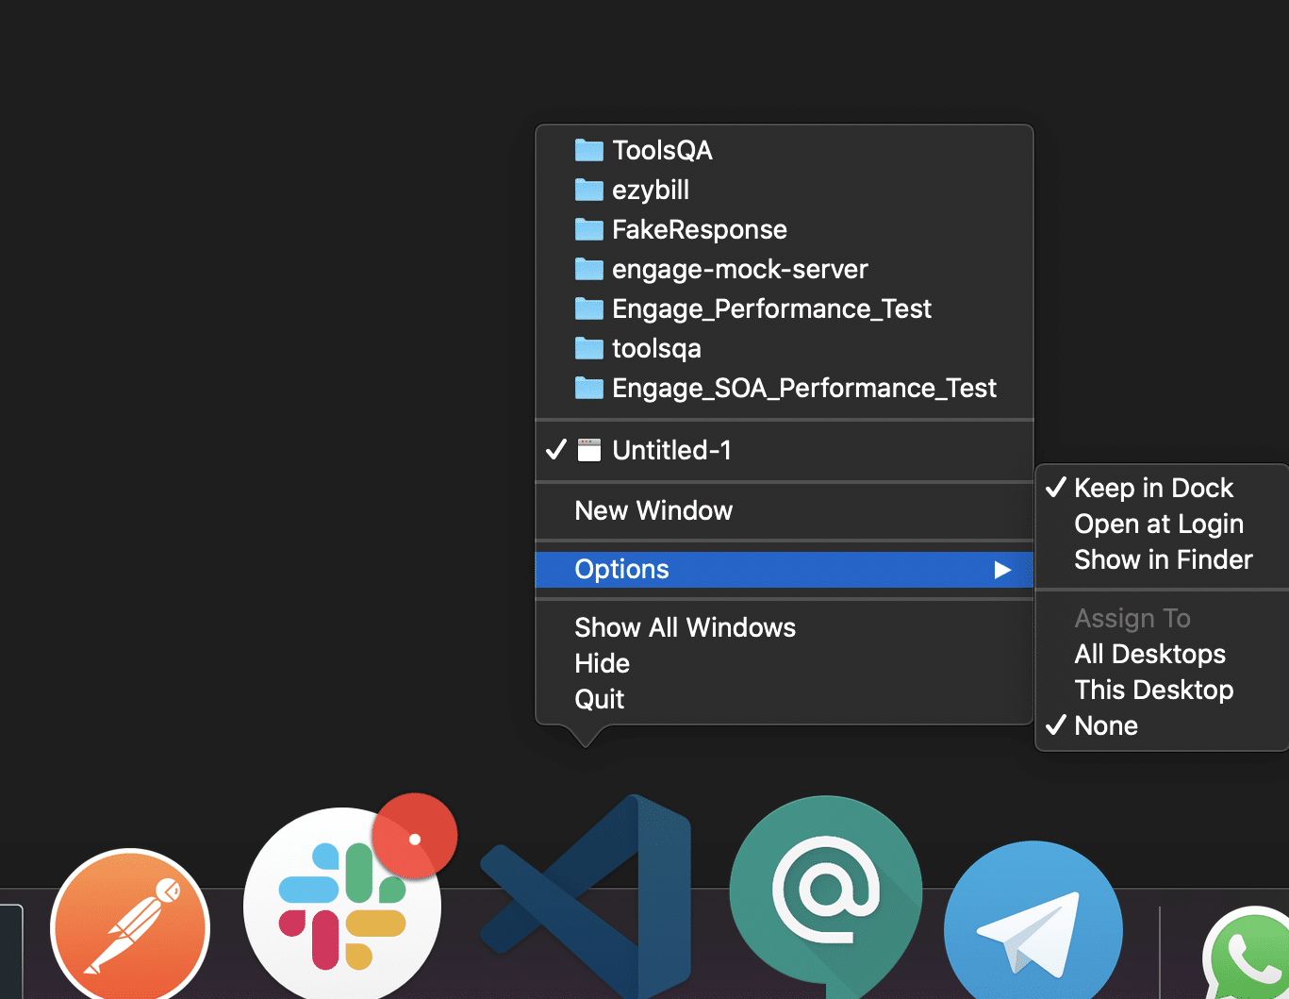

Fig 8.2 Downloading in mac

### **How to Install Visual Studio Code on Windows?**

Firstly, download the Visual Studio Code installer for Windows. Once it is downloaded, run the installer (VSCodeUserSetup-{version}.exe). It will only take a minute.

Secondly, accept the agreement and click on next.

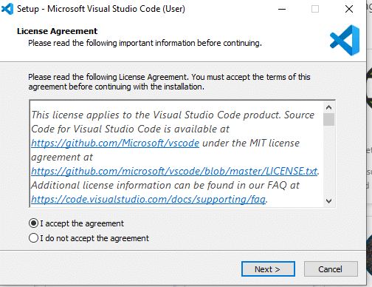

Fig 8.3 Setup of visual studio code

Thirdly, click on **"create a desktop icon"** so that it can be accessed from desktop and click on Next.

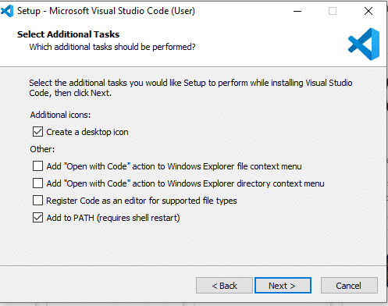

Fig 8.4 Procedure of Installation

After that, click on the install button.

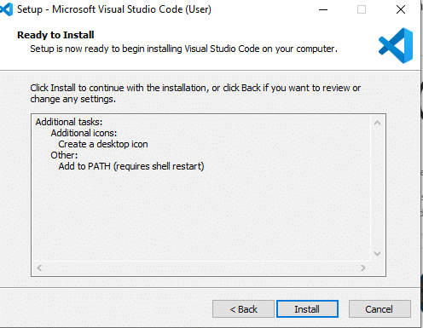

Fig 8.5 Procedure of Installation (2)

Finally, after installation completes, click on the finish button, and the visual studio code will get open.

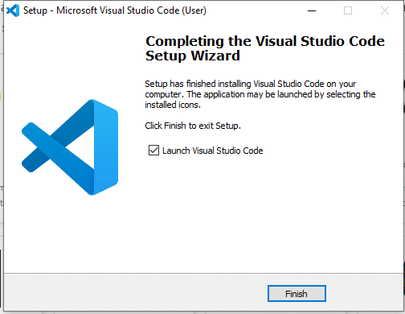

Fig 8.6 Installation Completed

By default, VS Code installs under C:\users{username}\AppData\Local\Programs\Microsoft VS Code.

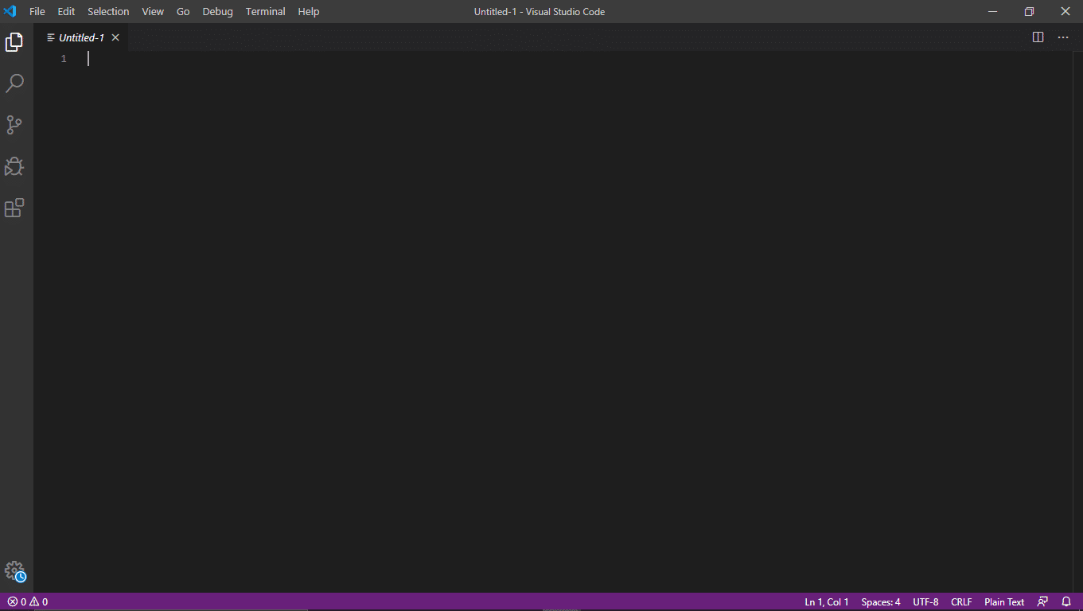

Fig 8.7 Main Screen of Visual Studio Code

### **INSTALLATION OF DJANGO**

Step 1 — Opening PowerShell

First, you need to open PowerShell on your computer. You can do that by searching for PowerShell in the Windows search box or you can open the **Run** dialog box by holding the **Windows logo key** and **R**(WIN+R). Once the dialog is open, type powershell, and then click **OK**.

You should now have the PowerShell window opened.

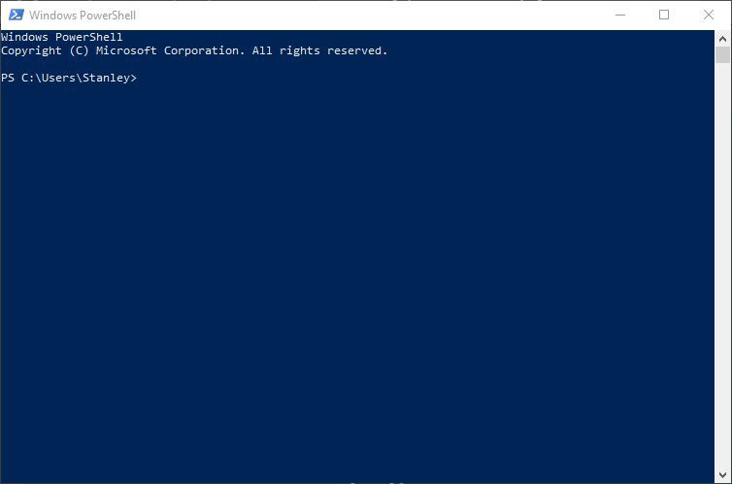

Fig 8.8 PowerShell

Now that you have opened PowerShell on your computer, you’ll verify the installation of Python in the next section.

Step 2 - Verifying Python Installation

Before you install Django, first, you need to make sure that you installed Python on your system.

To do that, type the following command in PowerShell prompt to verify the installation:

|  |  |
| --- | --- |
| > python -V | |
| -V | option logs the Python version installed on your system. |
|  |

After running the command, you should see output like this:

#### PS C:\Users\Username> python -V Python 3.9.7

At the time of writing, it is Python 3.9.7. You might have a different version from mine, and that’s fine. As long as you see the Python version logged, Python is installed on your system.

Now that you’ve confirmed Python is installed on your system, you will upgrade pip.

Step 3 - Upgrading Pip

Python comes with pip by default. But most of the time, it comes with an old version. It’s always a good practice to upgrade pip to the latest version.

Enter the following command to upgrade pip on your system:

#### > python -m pip install --upgrade pip

You’ll get output identical to the following screenshot showing you that the upgrade was a success:

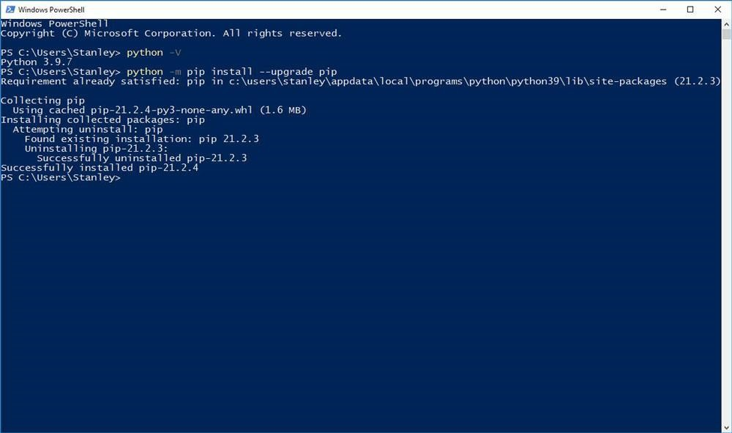

Fig 8.9 Upgrade Python

Now you’ve upgraded pip, you’ll create the project directory where you’ll install Django.

tep 4 - Creating a Project Directory

In this section, you will create a directory that will contain your Django application. We will name it django_project since this tutorial is a demo. But in a real project, you can give the directory a suitable name, such as forum, blog, etc.

Change into your Desktop directory with the cd command:

>

cd

Desktop

Create the directory using the

mkdi

r

command:

>

mkdir

django_project

Move into the

django_project

directory using the

cd

command:

>

cd

django_project

Your prompt should now show you that you’re in the

django_project

directory as shown in the

following output:

|  |
| --- |
| PS C:\Users\Stanley\Desktop\django_project> |

Now that you’ve created the working directory for your project, you’ll create a virtual environment where you’ll install Django.

Step 5 - Installing Django

In this section, you will install Django on your system using pip.

Run the following command to install Django using pip install:

|  |
| --- |
| (venv)> pip install django |

The command will install the latest version of Django. You should see Django being downloaded as shown in the following screenshot:

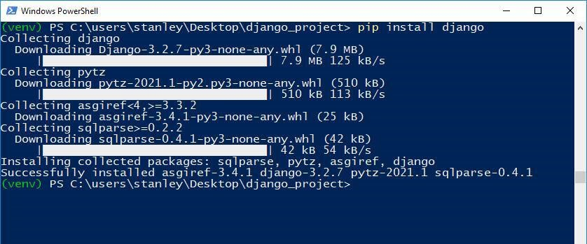

Fig 8.10 Install Django

If you want to install a different Django version, you can specify the version as follows:

#### (venv)> pip install django==3.1

Once the installation finishes, you need to verify that Django has been installed. To do that, type the following command:

|  |  |  |
| --- | --- | --- |
| (venv)> django-admin --version | | |
| You will get output showing you the Django version installed on your system: | | |
| (venv) PS C:\users\stanley\Desktop\django_project> django-admin --version  3.2.7 | | |
| At the time of writing, the latest Django version is | 3.2.7 | , and that’s why my output shows that. |
|  |

You’ve now installed Django on your system, great job! You’ll begin to create a Django project.

Step 6 - Creating the Django Project

Now it’s time to create a project. A project has a different meaning from what you may be used to. The [Django documentation](https://docs.djangoproject.com/en/3.2/glossary/#term-project) defines it as:

A Python package – i.e., a directory of code – that contains all the settings for an instance of Django. This would include database configuration, Django-specific options and applicationspecific settings.

You create a project by using the command-line utility django-admin that comes with Django. The command generates files where you can configure the settings for your database, add thirdparty packages for your project to mention a few.

Create the project using the django-admin startproject command:

|  |  |  |
| --- | --- | --- |
| (venv)> django-admin startproject test_project | | |
| Change into the | test_project | directory: |
|  |
| (venv)> cd test_project | | |
| Type the following command to see the contents in the project directory: | | |
| (venv)> ls test_project | | |
| You will get output similar to this: | | |
| (venv) PS C:\users\stanley\Desktop\django_project\test_project> ls    Directory: C:\users\stanley\Desktop\django_project\test_project    Mode LastWriteTime Length Name    ---- ------------- ------ ----    d----- 9/4/2021 1:25 AM test_project | | |

#### -a---- 9/4/2021 1:25 AM 690 manage.py

The directory test_project contains Django configuration files. The manage.py file comes in handy when starting a development server, and that’s what you will do in the next step.

Step 7 - Running the Development Server

Now that the project has been created, we will start the Django development server.

Start the development server using the manage.py runserver command:

(

venv)> python manage.py

runserver

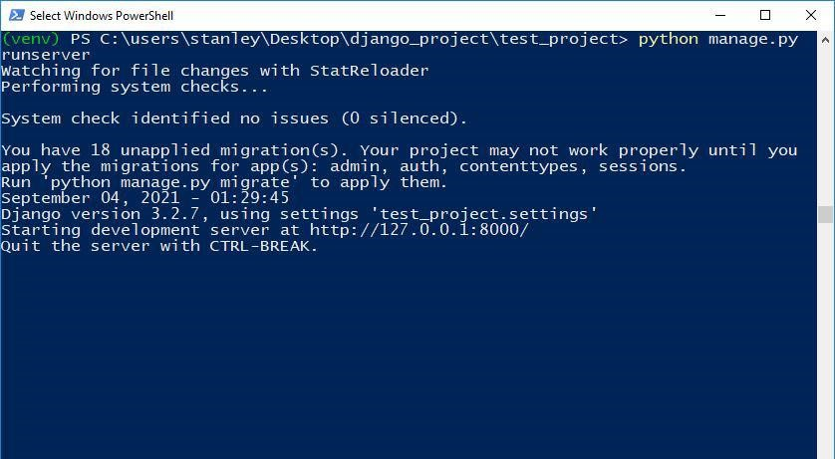

Fig 8.11 Running the Development Server

Next, visit<http://127.0.0.1:8000/>in your web browser. You should see a page similar to the following screenshot:

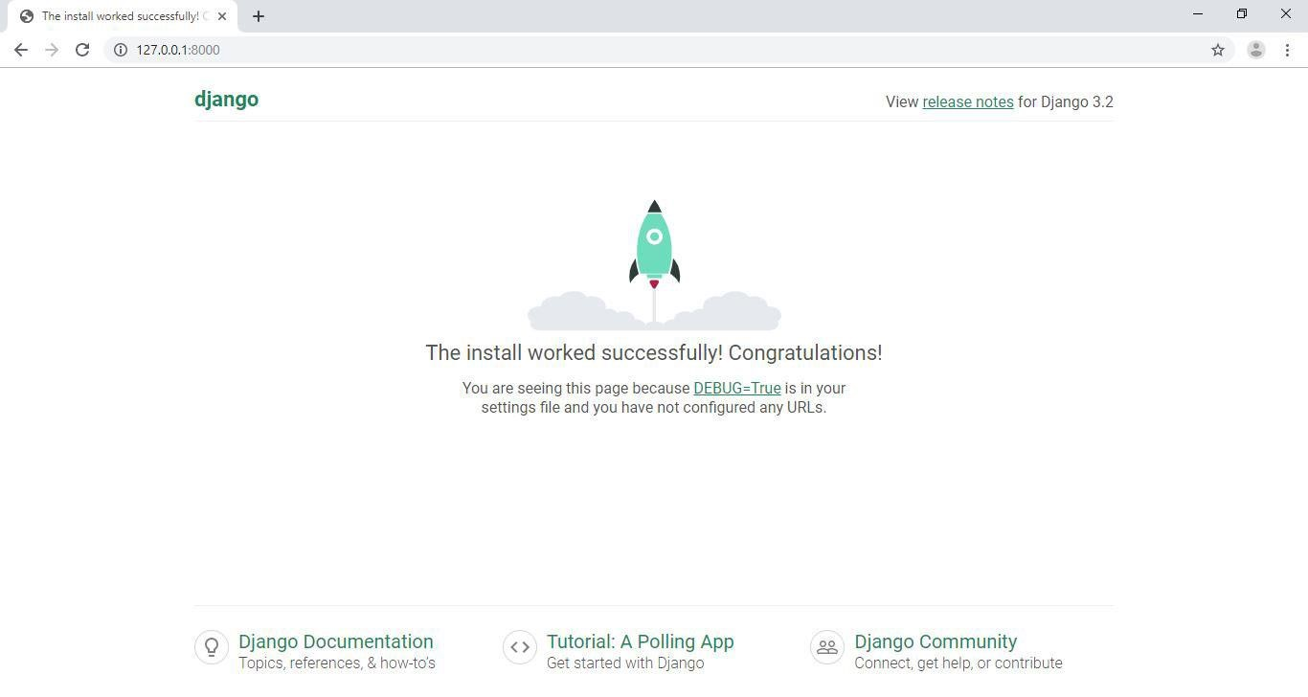

Fig 8.12 Successfully run project

**Tip** You can stop the server by holding CTRL+C. To deactivate the virtual environment, you can type deactivate on the prompt.

Now, you are ready to start developing your project.

**APPENDIX-1 GLOSSARY OF TERMS**

|  |  |
| --- | --- |
| **A** |  |
| **Admin** | An administrator is someone who can make changes on a computer that will affect other users of the computer. Administrators can change security settings, install software and hardware, access all files on the computer, and make changes to other user accounts. |
| **C** |  |
| **CSS** | CSS stands for Cascading Style Sheets. It is the language for describing the presentation of Web pages, including colours, layout, and fonts, thus making our web pages presentable to the users. CSS is designed to make style sheets for the web |
| **E** |  |
| **EMS** | Event Management System is a tool to assist organizers with the planning, execution, and management of their events. Examples of such events include music concerts, conferences, exhibitions, festivals, ceremonies, sporting events, and many more. |
| **D** |  |
| **Database** | A database is an organized collection of structured information, or data, typically stored electronically in a computer system. A database is usually controlled by a database management system (DBMS) |
| **G** |  |
| **GUI** | A graphics-based operating system interface that uses icons, menus, and a mouse (to click on the icon or pull down the menus) to manage interaction with the system. |
|  |  |
| **H** |  |
| **Html** | HTML, in full hypertext markup language, a formatting system for displaying material retrieved over the Internet. ... HTML markup tags specify document elements such as headings, paragraphs, and tables. They mark up a document for display by a computer program known as a Web browser. |
| **J** |  |
| **JavaScript** | JavaScript (JS) is a scripting language, primarily used on the Web. It is used to enhance HTML pages and is commonly found embedded in HTML code. JavaScript is an interpreted language. Thus, it doesn't need to be compiled. JavaScript renders web pages in an interactive and dynamic fashion. |
| **R** |  |
| **RAM** | RAM is short for “random access memory” and while it might sound mysterious, RAM is one of the most fundamental elements of computing. RAM is the super-fast and temporary data storage space that a computer needs to access right now or in the next few moments. |
| **U** |  |
| **User** | To use something is to employ it or operate it, so a user is someone who uses or takes advantage of something. If you have a computer and use it for anything, you're a computer user. |

**REFERENCES**

**WEBSITES**

1. **Icon**

<https://www.sistecgn.ac.in/>

1. **Images**

<https://www.sistecgn.ac.in/>

1. **Django Tutorial**

<https://www.youtube.com/watch?v=C1NgOmoOszc&list=PLjVLYmrlmjGcyt3m6rt21nfjhYSWP_Ue_>

1. **Python**

<https://docs.python.org/3/>

**PROJECT SUMMARY**

***About Project***

|  |  |
| --- | --- |
| **Title of the project** | **Event Management System- A Smart Way to manage Events** |
| **Semester** | 8th |
| **Members** | 4 |
| **Team Leader** | Harsh Khare |
| **Describe role of every member in the project** | Front-end implementation: - Harsh Khare, Divyanshi Pandey, Ankit Vishwakarma and Geetanjali Kushwaha  Back-end implementation: - Harsh Khare, Divyanshi Pandey, Ankit Vishwakarma and Geetanjali Kushwaha  Design And Documentation: - Harsh Khare, Divyanshi Pandey, Ankit Vishwakarma and Geetanjali Kushwaha |
| **What is the motivation for selecting this project?** | As we all know that for the successful execution and conduction of the event there exists, an Administrator, Event Head, and Coordinators who manage these events and execute them, for ease of these, time-saving for smooth execution without any error, or problem. We want to solve this issue |
| **Project Type**  **(Desktop Application, Web Application, Mobile App, Web)** | Web Application |

***Tools &Technologies***

|  |  |
| --- | --- |
| **Programming language**  **used** | HTML, CSS, JavaScript, Django |
| **Compiler used**  **(With version)** | Google Chrome Version 111.0.4664.45 |
| **IDE used**  **(With version)** | Visual Studio Code Version 1.62 |
| **Front End Technologies**  **(With version, wherever**  **Applicable)** | HTML Version 5.3  CSS Version 3  JavaScript Version ES2015 |
| **Back End Technologies**  **(With version, wherever**  **applicable)** | Django Version 4.0.4 |
| **Database used**  **(With version)** | Yes, SQLite Version 3.8 |

***Software Design & Coding***

|  |  |
| --- | --- |
| **Is prototype of the software developed?** | - |
| **SDLC model followed**  **(Waterfall, Agile, Spiral etc.)** | Spiral Model |
| **Why above SDLC model is followed?** | Because Software is deployed more quickly and improved more regularly |
| **Justify that the SDLC model mentioned above is followed in the project.** | Website is deployed more quickly and improved more regularly |
| **Software Design approach followed**  **(Functional or Object-oriented)** | Object oriented Approach |
| **Name the diagrams**  **developed**  **(According to the Design**  **approach followed)** | ER Diagram  Use Case Diagram  Class Diagram |
| **In case Object Oriented**  **approach is followed, which of the OOPS principles are**  **covered in design?** | Inheritance  Polymorphism  Abstraction  Encapsulation |
| **No. of Tiers**  **(Example 3-tier)** | - |
| **Total no. of front-end pages** | 20 |
| **Total no. of tables in database** | 14 |
| **Database is in which Normal Form?** | - |
| **Are the entries in database encrypted?** | No |
| **Front end validations applied (Yes / No)** | Yes |
| **Session management done**  **(In case of web applications)** | No |
| **Is application browser compatible**  **(In case of web applications)** | Yes |
| **Exception handling done**  **(Yes / No)** | Yes |
| **Commenting done in code (Yes / No)** | Yes |
| **Naming convention followed**  **(Yes / No)** | Yes |
| **What difficulties faced during deployment of project?** | - |
| **Total no. of Use-cases** | 1 |
| **Give titles of Use-cases** | - |

***Project Requirements***

|  |  |
| --- | --- |
| **MVC architecture followed**  **(Yes / No)** | No |
| **If yes, write the name of**  **MVC architecture followed**  **(MVC-1, MVC-2)** | - |
| **Design Pattern used**  **(Yes / No)** | No |
| **If yes, write the name of**  **Design Pattern used** | - |
| **Interface type**  **(CLI / GUI)** | GUI |
| **No. of Actors** | 4 |
| **Name of Actors** | Admin, Coordinator, Event Head and Participants |
| **Total no. of Functional**  **Requirements** | 16 |
| **List few important non-**  **Functional Requirements** | Usability  Reliability  Performance  Availability  Extensibility  Security  Maintainability  Supportability |

***Testing***

|  |  |
| --- | --- |
| **Which testing is performed?**  **(Manual or Automation)** | Manual |
| **Is Beta testing done for this**  **project?** | No |

***Write project narrative covering above mentioned points***

|  |
| --- |
| Applicants should identify and provide a brief description for each data/IT management/ technological solution they will be utilizing in their project. For each solution identified, applicants should also detail why this technology is appropriate for the project, which business/administrative need(s) it helps to meet, and why the applicant feels confident in their ability to successfully implement and maintain the solution. |

|  |  |  |  |
| --- | --- | --- | --- |
| Ankit Vishwakarma  0187CS191028 |  |  | Guide Signature  Prof. Jai Mungi |
| Divyanshi Pandey  0187CS191049 |  |  |
| Geetanjali Kushwaha  0187CS191054 |  |  |
| Harsh Khare  0187CS191060 |  |  |